[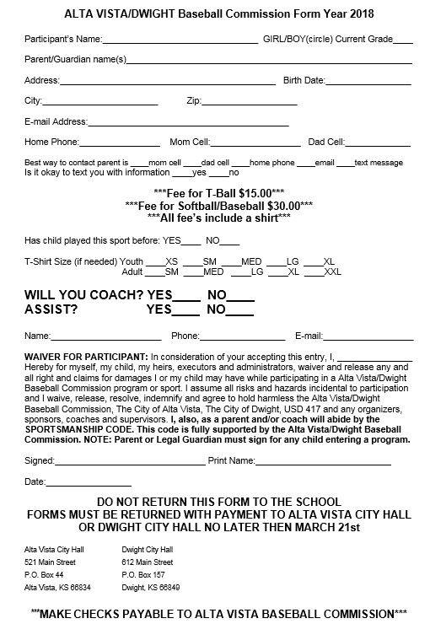](http://dwightks.net/wp-content/uploads/2016/03/2018-Baseball-Softball-Sign-up-form.jpg)